Equivalent Output Resistance

Consider this simple circuit:

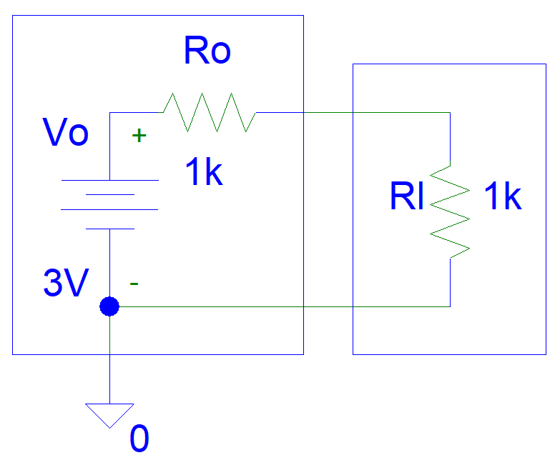
Figure 1: System Circuit

Convert to equivalent resistance:

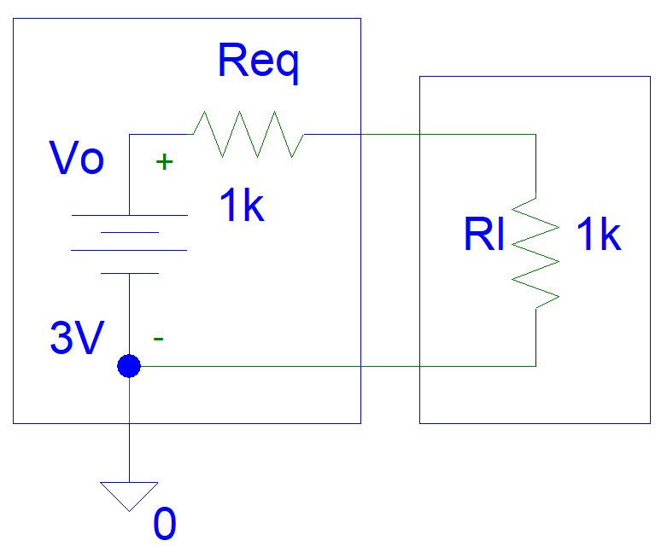
Figure 2: Converting to equivalent resistance

Req = (Vo - Vl) / Il
= (Vo - Vl) / (Vo / (Rl + Ro))
= (Vo - Vo * Rl / (Rl + Ro)) / (Vo / (Rl + Ro))
= (1 - Rl / (Rl + Ro)) * (Rl + Ro)
= (Rl + Ro) - Rl
= Rol

Suppose we add an additional current source:

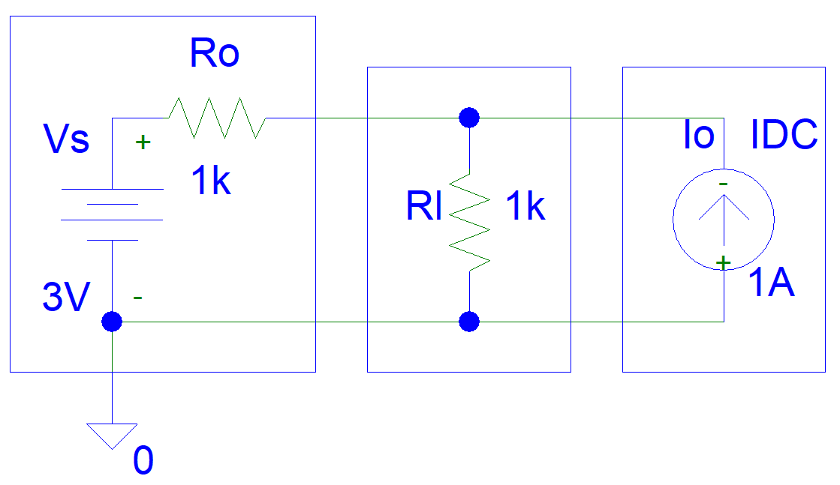
Figure 3: System with extra current source

Convert to equivalent resistance:

Figure 4: Converting to equivalent resistance

Using superposition theorem:
Req = (Vo - Vl) / Il
= (Vo - Vl) / (Vo / (Rl + Ro) + Io)
= (Vo - Vo * Rl / (Rl + Ro) - Io * Rl) / (Vo / (Rl + Ro) + Io)
= (1 - Rl / (Rl + Ro) - Io * Rl / Vo) / (1 / (Rl + Ro) + Io / Vo)

Increasing the Io value will reduce the equivalent resistance.

Suppose we replace the current source with a voltage source:

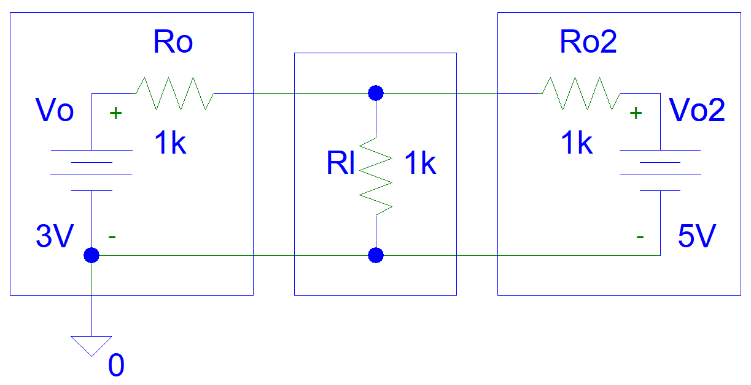
Figure 5: System with extra voltage source

Convert to equivalent resistance:

Figure 6: Converting to equivalent resistance

Using superposition theorem:

Req = (Vo - Vl) / Il

= (Vo - Vl) /
(Vo * (Rl||Ro2) / (Rl||Ro2 + Ro) / Rl +
+ Vo2 * (Rl||Ro) / (Rl||Ro + Ro2) / Rl)

= (Vo - Vo * (Rl||Ro2) / (Rl||Ro2 + Ro)
- Vo2 * (Rl||Ro) / (Rl||Ro + Ro2)) /
(Vo * (Rl||Ro2) / (Rl||Ro2 + Ro) / Rl +
+ Vo2 * (Rl||Ro) / (Rl||Ro + Ro2) / Rl)

Dr Mark Glickman, drmarkglickman@gmail.com

